April 14, 2019

To Whom It May Concern:

I am writing this letter to request that you excuse ____________________________________ from attendance to allow for their participation in the services of Holy Thursday and Holy Friday. Our commemoration of our Lord’s Passion in Holy Week is our most sacred and solemn week of the entire year. Our services will be held on Thursday morning, April 25 until 11 AM and on Holy Friday, April 26, (called “Good Friday” in the Western Churches), vigil is held the entire day, beginning at 12 Noon.

I appreciate your understanding and accommodation of our religious practice. Please feel free to call me at (616) 216-3537 (cell) or email me at frmichaeln@gmail.com if you have any questions.

Respectfully,
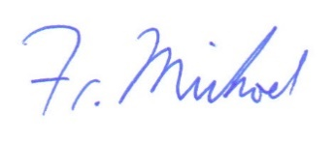
V. Rev. Michael Nasser
Pastor, St. Nicholas Orthodox Church

